Homework Questions?

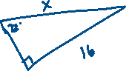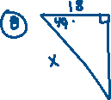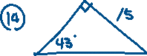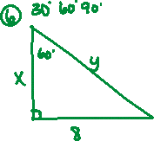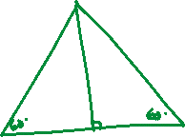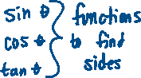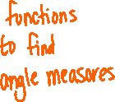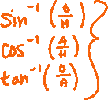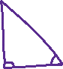

A kite, flying 50 feet high in the air, is attached to a string to a stake in the sand. The angle of elevation with the ground is 32o. How long is the string to he nearest foot?

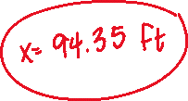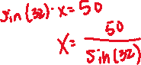

A tree’s shadow is measured to be 60 feet long. If the sun’s angle of elevation is 57 degrees, then how tall is the tree?

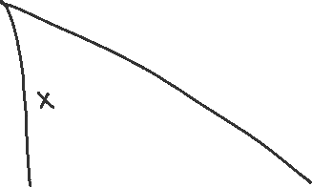

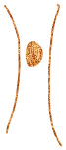



How can we solve these problems??



A ten foot pole casts a 30 foot shadow. What is the angle that the sun makes with the ground, to the nearest degree?

