Find the surface area of spheres. | $$S=4πr^{2}$$ | - Find the surface area of the sphere. | 2. What is the diameter of a sphere with a surface area of 44$π$ ${cm}^{2}$?
Find the volume of spheres. | $$V=\frac{4}{3}πr^{3}$$ | 3. A beach ball has a diameter of 8 inches. Find its volume. | 4. Find the volume of the hemisphere.
Find the volume of prisms and cylinders. | V=Bh  (where B is the area of the base)  A_{Rectangle}= bh  A_{Circle}= πr²  A_{Triangle}= ½ bh  A_{Trapezoid} = ½(b₁+b₂)h | 5. Find the volume.  4 m  2 m  10 m | 6. Find the volume.  12 in  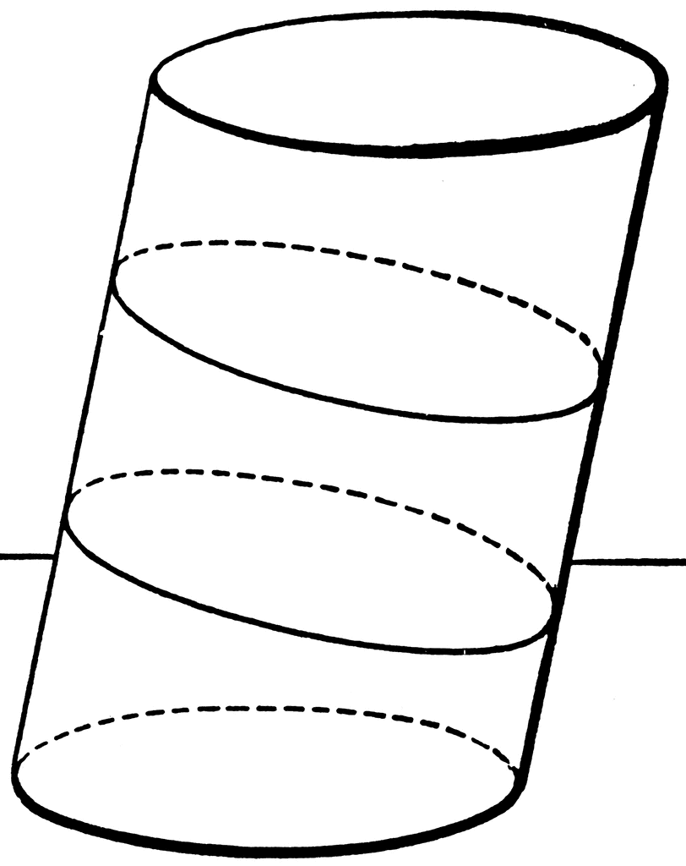  20 in
7. Find the volume.  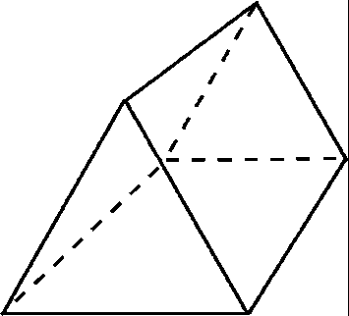  22cm  25cm  21 cm  35 cm |  | 8. Find the volume.  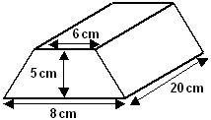
Find the volume of pyramids and cones. | V = 1/3 Bh | 9. Find the volume.  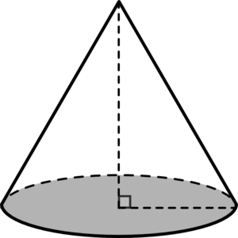  15.8 yd  15 yd  5 yd | 10. Find the volume.  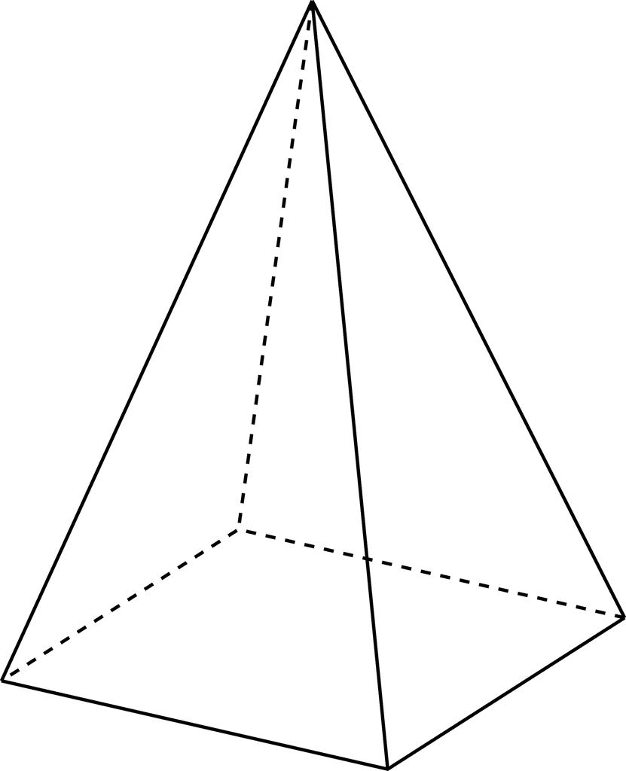  44 in  28 in  30 in

