Piecewise Word Problems

- You have a summer job that pays time and a half for overtime. (If you work more than 40 hours)After that it is 1.5 times your hourly rate of $7.00/hr.

- Write a piecewise function to represent this problem.

- How much money do you make if you work 45 hours?

- Your cell phone plan costs $75/month and gives you unlimited talk, and 500 text messages per month, and no data plan. After 500 text messages, it costs $.10 per text you send.

- Write a piecewise function to represent this situation.

- How much will it cost if you send 750 text messages/

- You go to Kroger to buy some candy. You decide to buy snickers because they have a special deal on snickers. A bag of snickers costs $3.45, but if you buy 4 or more bags, they only cost $3.00 per bag.
  - Write a piecewise function to represent this situation.

  - How many bags of snickers can you purchase if you have $13.00? $22.50?

- A car rental company charges a flat fee of $45 to rent a car. In addition to that you must pay a fee per day you rent it. If you keep the car for 3 days or less, it costs $7 per day. If you keep the car longer than 3 days it only costs $5 per day.
  - Write a piecewise function to represent this situation.
  - How much does it cost to rent for 3 days? 4 days? What is weird about this?

- One ISP (Internet Service Provider) has the following rate schedule for high speed internet service. Monthly Service Charge - $18.00First 50 Hours of Usage – Free. Next 50 hours of Usage - $0.25/hour Over 100 hours of Usage - $1.00/hour.

  - Write a piecewise function to represent this situation. Be Careful. Remember if you use 51 hours, you will only be charged for one hour because the first 50 are free. Check your work!

  - How much would you be charged for 162 hours of service?

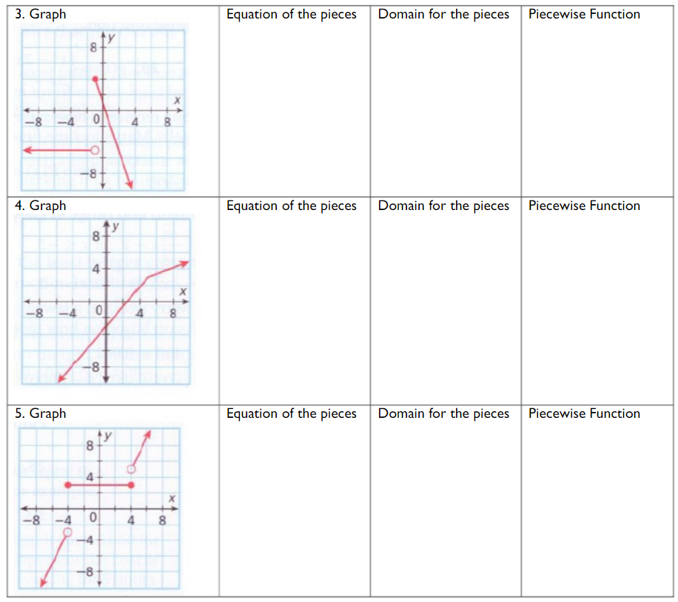
Piecewise Graphs

