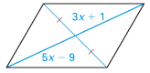**Find the missing variable in each parallelogram.**

1. 2.

3x + 1



5x - 9

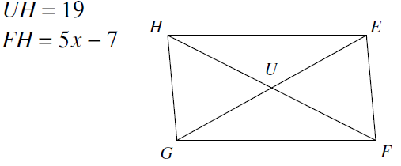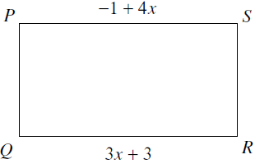

3. 4.

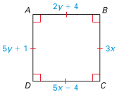

2y + 4

5.

5y + 1

3x

5x - 4

**Decide if the figure is a parallelogram. If yes, can you identify the type of parallelogram? If it is not, explain why not.**

6. 7.

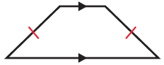 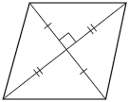

8. 9.

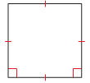 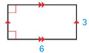

**Parallel Lines and Transversals**

Solve for the missing variables.

|  |  |  |
| --- | --- | --- |
| 10. | 11. | 12. |

**Congruent Triangles**

13. Prove that opposite sides in a parallelogram are congruent. Use the figure below. (HINT: Draw in triangles!)

D

C

Given: AB *ll* CD and AC *ll* BD  
 Prove: AB $≅$ CD and AC $≅$ BD

B

A

**Prove the following**.

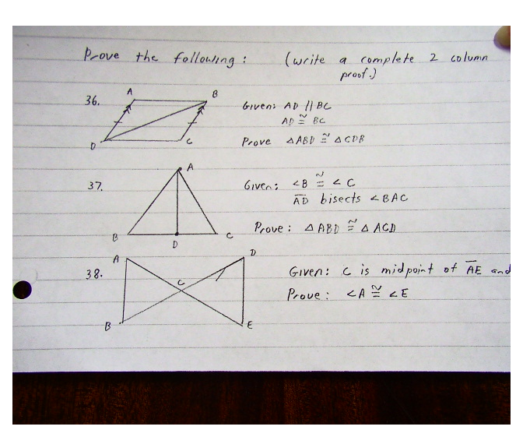14. Given: AD *ll* BC and AD $≅$ BC  
 Prove: ABD CDB

15. Given: <B $≅$ <C and AD bisects < BAC  
 Prove: ABD ACD

16. Given: C is the midpoint of AE and BD  
 Prove: ACB $≅$ EDC