OUR TURN |  |  |  |  | YOUR TURN
1. |  | Use this triangle to complete the statements and justifications below. |  | 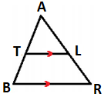 | 1. |  | Use this triangle to complete the statements and justifications below. |  | 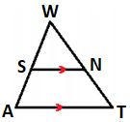
Step Statement Justification  1 TL is parallel to BR. Given  2 ∠ATL ≅ ∠______ ∠ALT ≅ ∠______  3 ΔATL ∼ Δ_______  4 $$\frac{AB}{AT}=\frac{ }{ }$$  5 $$\frac{TB+AT}{AT}=\frac{ }{ }$$ Segment Addition Postulate  6 $$\frac{TB}{AT}=\frac{ }{ }$$ Subtraction Property of Equality |  |  |  |  | Step Statement Justification  1 GK is parallel to HJ. Given  2 ∠WSN ≅ ∠______ ∠WNS ≅ ∠______  3 ΔWSN ∼ Δ_______  4 $$\frac{WA}{WS}=\frac{ }{ }$$  5 $$\frac{SA+WS}{WS}=\frac{ }{ }$$ Segment Addition Postulate  6 $$\frac{SA}{WS}=\frac{ }{ }$$ Subtraction Property of Equality
2. |  | Use this triangle to complete the statements and justifications below. |  | 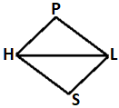 | 2. |  | Use this triangle to complete the statements and justifications below. |  | 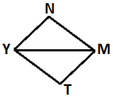
Step Statement Justification  1 PH ≅ SL Given  2 ∠PHL ≅ ∠SLH Given  3 HL ≅ LH ?  4 ΔPHL ≅ ΔSLH ? |  |  |  |  | Step Statement Justification  1 ∠N ≅ ∠T Given  2 ∠NMY ≅ ∠TYM Given  3 MY ≅ YM ?  4 ΔNYM ≅ ΔTMY ?
3. |  | Use these lines to complete the statements and justifications below. |  | 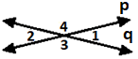 | 3. | Use these lines to complete the statements and justifications below. |  |  | 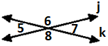
Step Statement Justification  1 Line p intersects line q. Given  2 ∠1 and ∠3 are a linear pair. ∠2 and ∠3 are a linear pair. Definition of Linear Pair  3  4  5 Subtraction Property  6 Definition of Congruent Angles |  |  |  |  | Step Statement Justification  1 Line j intersects line k. Given  2 ∠5 and ∠6 are a linear pair. ∠6 and ∠7 are a linear pair. Definition of Linear Pair  3  4  5 Subtraction Property  6 Definition of Congruent Angles
OUR TURN |  |  |  |  | YOUR TURN
4. | Use this line and triangle to complete the statements and justifications below. |  | 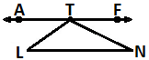 |  | 4. |  | Use this line and triangle to complete the statements and justifications below. | 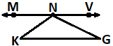
LN and $\overset{⃡}{AF}$ are parallel, so LT is a transversal.  The _________________________________ formed by the transversal are congruent.  So, m∠L = m∠______.  Similarly, TN is a transversal, so m∠N = m∠______.  The sum of the angle measures that make a straight line is _____°.  So, m∠_____ + m∠_____ + m∠_____ = 180°.  Now, substitute m∠L for m∠______ and m∠N for m∠______ to get m∠___ + m∠LTN + m∠___ = 180°. |  |  |  |  | KG and $\overset{⃡}{MV}$ are parallel, so KN is a transversal.  The _________________________________ formed by the transversal are congruent.  So, m∠K = m∠______.  Similarly, NG is a transversal, so m∠G = m∠______.  The sum of the angle measures that make a straight line is _____°.  So, m∠_____ + m∠_____ + m∠_____ = 180°.  Now, substitute m∠K for m∠______ and m∠G for m∠______ to get m∠___ + m∠KNG + m∠___ = 180°.
5. |  | Use this parallelogram to complete the statements and justifications below. |  |  | 5. |  | Use this parallelogram to complete the statements and justifications below. |  | 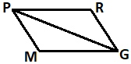
Step Statement Justification  1 QUDL is a parallelogram. Given  2 UL is a diagonal. Given  3 QU ǁ LD, QL ǁ UD  4 ∠QUL ≅ ∠______ ∠QLU ≅ ∠______  5 UL ≅ ______  6 ΔQUL ≅ Δ______  7 QU ≅ DL |  |  |  |  | Step Statement Justification  1 PRGM is a parallelogram. Given  2 PG is a diagonal. Given  3 PR ǁ MG, PM ǁ RG  4 ∠RPG ≅ ∠______ ∠RGP ≅ ∠______  5 PG ≅ ______  6 ΔPRG ≅ Δ______  7 PM ≅ GR
6. |  | Use this triangle and perpendicular bisector to complete the statements and justifications below. |  | 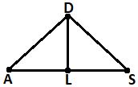 | 6. |  | Use this triangle and perpendicular bisector to complete the statements and justifications below. |  |  | 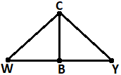
Step Statement Justification  1 DL is the perpendicular bisector of AS. Given  2 AL ≅ ____  3 DL ≅ ____  4 ∠ALD and ∠______ are right angles.  5 ∠ALD ≅ ∠______  6 ΔALD ≅ Δ______  7 AD ≅ SD |  |  |  |  | Step Statement Justification  1 CB is the perpendicular bisector of WY. Given  2 WB ≅ ____  3 CB ≅ ____  4 ∠WBC and ∠______ are right angles.  5 ∠WBC ≅ ∠______  6 ΔWBC ≅ Δ______  7 WC ≅ YC

OUR TURN |  |  |  |  | YOUR TURN
7. | Use this triangle to complete the statements and justifications below. You will need to construct an auxiliary line for Step 2. |  |  | 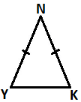 | 7. |  | Use this triangle to complete the statements and justifications below.  You will need to construct an auxiliary line for Step 2. |  |  | 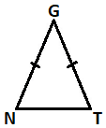
Step Statement Justification  1 YN ≅ ___ Given  2 Construct NW, the angle bisector for ∠___, where W is on ____. Every angle has a ________________.  3 ∠YNW ≅ ∠______  4 NW ≅ _____  5 ΔYNW ≅ Δ______  6 ∠Y ≅ ∠___ |  |  |  |  | Step Statement Justification  1 NG ≅ ___ Given  2 Construct GS, the angle bisector for ∠___, where S is on ____. Every angle has a ________________.  3 ∠NGS ≅ ∠______  4 GS ≅ _____  5 ΔNGS ≅ Δ______  6 ∠N ≅ ∠___
8. | Use this parallelogram to complete the statements and justifications below. |  | 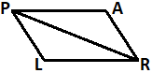 |  | 8. | Use this parallelogram to complete the statements and justifications below. |  |  | 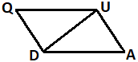
Step Statement Justification  1 PARL is a parallelogram. Given  2 PR is a diagonal. Given  3 PA ǁ LR, PL ǁ AR  4 ∠LRP ≅ ∠______ ∠LPR ≅ ∠______  5 PR ≅ ______  6 ΔLRP ≅ Δ______  7 PL ≅ AR |  |  |  |  | Step Statement Justification  1 QUAD is a parallelogram. Given  2 DU is a diagonal. Given  3 QU ǁ DA, QD ǁ UA  4 ∠QUD ≅ ∠______ ∠QDU ≅ ∠______  5 DU ≅ ______  6 ΔQUD ≅ Δ______  7 QU ≅ DA
9. | In the diagram, line t is the transversal of parallel lines p and q. How can the relationship between ∠2 and ∠3 be written in three different ways? | 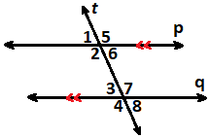 |  |  | 9. | In the diagram, line t is the transversal of parallel lines p and q. How can the relationship between ∠6 and ∠7 be written in three different ways?

OUR TURN |  | YOUR TURN
10. | 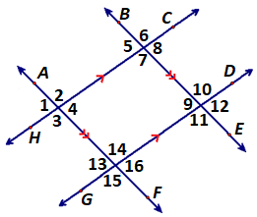  Given two sets of parallel lines in the diagram, describe the relationships between ∠4 and ∠10 using ∠14. | 10. | Given two sets of parallel lines in the diagram, describe the relationships between ∠6 and ∠16 using ∠11.
Response Problems
OUR TURN |  |  | YOUR TURN
11. | In ΔABC, segments LM, MN and NL are midsegments. If AM = 33, ML = 64 and CB = 108, then explain how to find the perimeter of ΔLMN. | 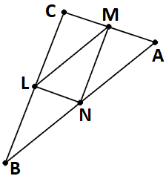 | 11. | In ΔABC, segments LM, MN and NL are midsegments. If NM = 37, NB = 36 and CA = 80, then explain how to find the perimeter of ΔLMN. | 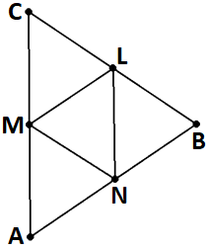
12. | Compare and contrast how to find the measure of ∠A in each triangle.  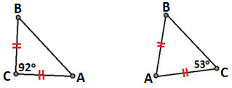 |  | 12. | Compare and contrast how to find the measure of ∠A in each triangle.  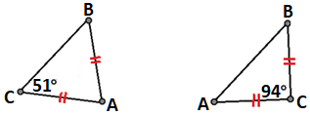
13. | Explain how to find the measure of ∠KRN in parallelogram NYRK.  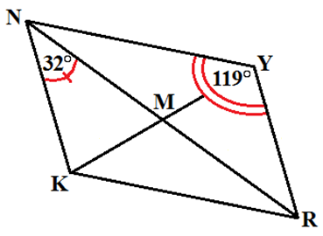 |  | 13. | Explain how to find the measure of ∠NMQ in parallelogram LMNQ.  