Name __________________________________________ Date: ______________________________

Use to find the value of *x*. Then, find the arc measures.

1. 
2. 

Find the measure of the indicated arc or angle in .

1. 
2. 
3. 

Find the value of each variable.

1. 
2. 
3. 

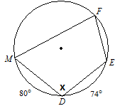

1. 

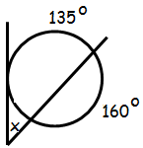

1.  
2. 

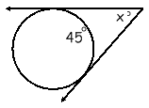

Find the **area** and **arc length** of the shaded region.



1. 
2. 

The radius of a pizza is 8 in. The pizza is cut into eighths.

1. Find the area of one piece of pizza. __________
2. Find the length of the crust on one piece of pizza. __________
3. Determine the radius of the circle with a circumference of . __________

Use the radius to then find the area. __________

1. A sprinkler system can shoot water at a distance of 15 yards. It is set up to rotate 240 degrees. How much area of the yard is covered by the sprinkler? __________
2. The clock in our classroom has a radius of 9 inches. If it’s 4:00, find the arc length and area of the sector for this time. & 