VOCABULARY
Paragraph Proof – a series of statements and reasons often displayed in a chart that works from given information to the statement that needs to be proven, but the information is presented as running text in paragraph form.
Linear Angles – three or more angles originating from the same point on a line whose sum is 180°.
Triangle Sum Theorem – the sum of the measures of a triangle is 180°.

For #1-2, complete the statements and justifications for each paragraph proof to prove the Triangle Sum Theorem.

1. | Given: $\overset{⃡}{XY}∥AC$  Prove:  m∠A + m∠ABC + m∠C =180° | 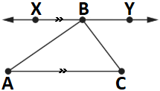 | 2. | Given: m || n  Prove:  m∠1 + m∠2 + m∠3 =180° | 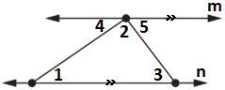

Paragraph Proof
It is given that line XY is parallel to line segment AC. This means _____ is a transversal. From the alternate interior angles theorem, the alternate interior angles formed by the transversal are congruent. This means m∠ABX = m∠____. Similarly, ____ is also a transversal with congruent alternate interior angles. So m∠CBY = m∠____. By the definition of linear angles,  m∠ABX + m∠ABC + m∠CBY =______°.  By substitution of m∠ABX for m∠____ and m∠CBY for m∠____, it is proved that m∠A + m∠ABC + m∠C =180°. |  | It is given that line m is ____________ to line n. From the alternate interior angles theorem, the alternate interior angles formed by the transversal are congruent. This means m∠4 = m∠____ and m∠5 = m∠____. By the definition of linear angles,  m∠4 + m∠2 + m∠5 =______°.  By substitution of m∠4 for m∠____ and m∠5 for m∠____, it is proved that m∠1 + m∠2 + m∠3 =180°.

For #3-8, a lighthouse forms a triangle with every pair of four buoys in an area of water.
Complete and use the chart to match and write the interior angles of the triangle for each diagram with the light house angle.
Angles | Left | Right | Light | 3.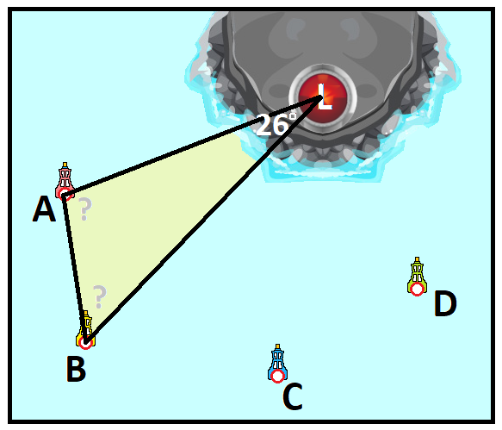 | 4.  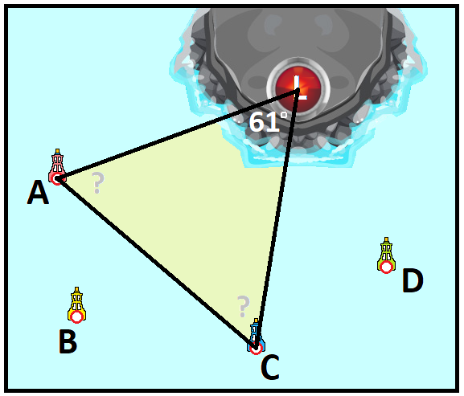 | 5.  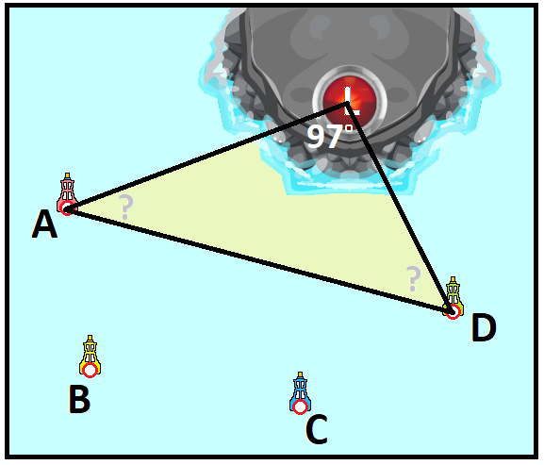
of … | Buoy | Buoy | House
Δ₁ | 35° | 48°
Δ₂ | 37° | 73°
Δ₃ | 49° | 95° |  | 6.  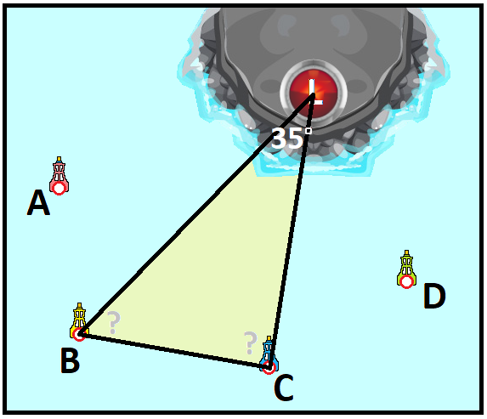 | 7.  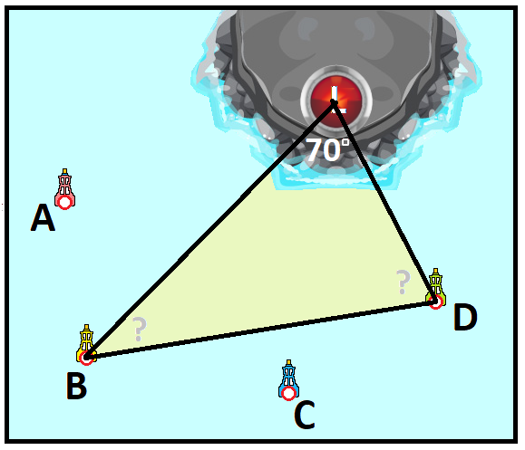 | 8.  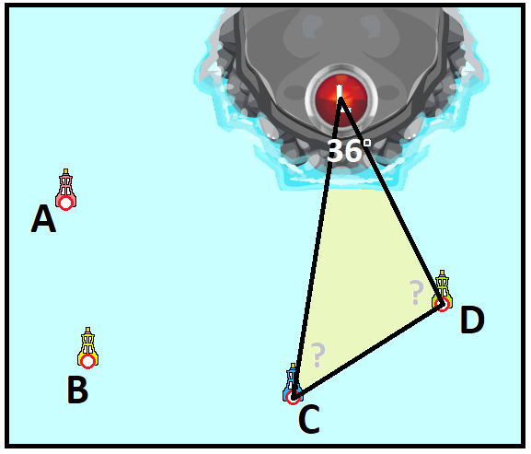
Δ₄ | 55° | 90°
Δ₅ | 60° | 59°
Δ₆ | 102° | 52°

For #9-14, write the measure of each numbered angle by applying prior knowledge of angle pairs and the triangle sum.
9.  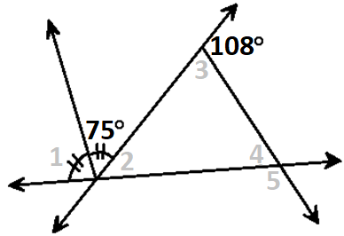 | 10.  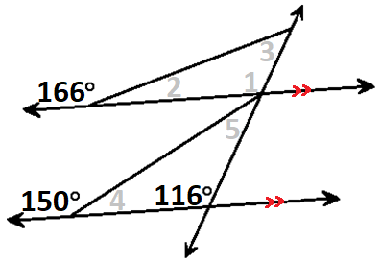 | 11. | 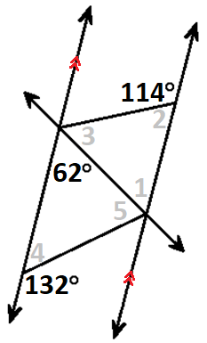
12.  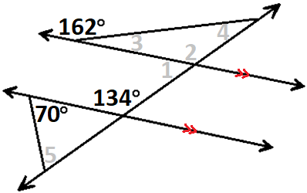 | 13.  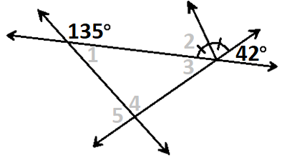 | 14. | 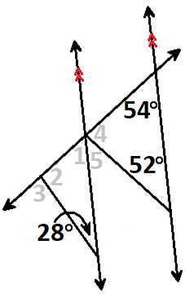

For #15-20, write the measure of each lettered angle by applying prior knowledge of angle pairs and the triangle sum.
15.  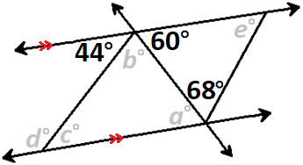 | 16. | 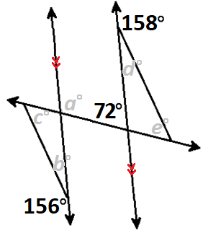 | 17. | 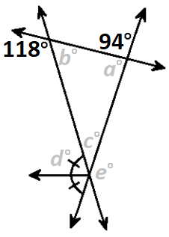
18.  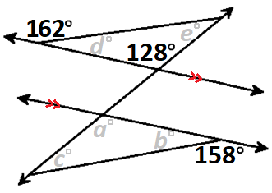 | 19.  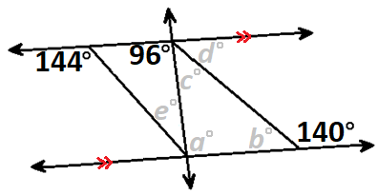 |  | 20.  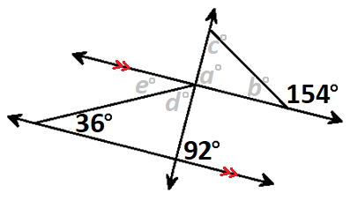

For #21-23, write the linear angles that match the triangle sum in each given triangle.
21. | 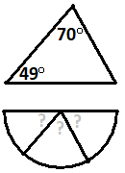 | 22. | 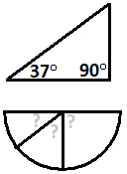 | 23. | 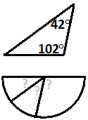
VOCABULARY
Auxiliary Line – a line drawn in a diagram that is often needed to complete a proof by making other figures like congruent triangles or angles formed by a transversal.
Isosceles Triangle – a triangle with at least two congruent sides called legs with the third side called the base.
Isosceles Triangle Theorem – If a triangle is isosceles, then the base angles opposite the congruent legs are congruent.

For #24-25, complete the statements and justifications for each two-column proof
to prove the Isosceles Triangle Theorem.
24. | Given: ΔSTU is isosceles  Prove: ∠S ≅ ∠U | 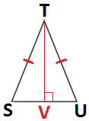 | 25. | Given: ΔABC is isosceles  Prove: ∠A ≅ ∠C | 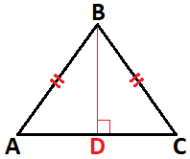

Step | Statement | Justification |  | Step | Statement | Justification
1 | ΔSTU is isosceles | Given |  | 1 | ΔABC is isosceles | Given
2 | ST ≅ _____ | Definition of isosceles triangle |  | 2 | AB ≅ _____ | Definition of isosceles triangle
3 | Construct TV, the perpendicular bisector of SU. | Every side has a perpendicular bisector |  | 3 | Construct BD, the perpendicular bisector of AC. | Every side has a perpendicular bisector
4 | TV ≅ ____ | Reflexive sides are congruent |  | 4 | BD ≅ ____ | Reflexive sides are congruent
5 | ΔSTV ≅ Δ_______ | Hypotenuse Leg (HL) |  | 5 | ΔABD ≅ Δ_______ | Hypotenuse Leg (HL)
6 | ∠S ≅ ∠U | Definition of congruent angles |  | 6 | ∠A ≅ ∠C | Definition of congruent angles

For #26-31, use a geomirror or mira on the dotted line of symmetry to form an isosceles triangle and find the measure of each interior angle. | 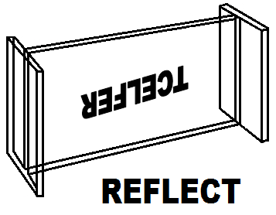
26.  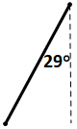 | 27.  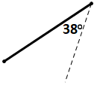 | 28.  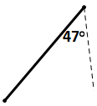
29.  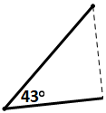 | 30.  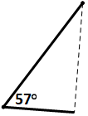 | 31.  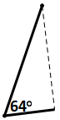
For #32-34, circle the parts of each isosceles triangle.
 | 32.  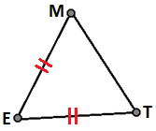 | 33.  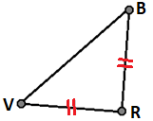 | 34.  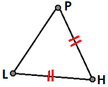
Legs | ME ET TM | BR RV VB | PH HL LP
Base | ME ET TM | BR RV VB | PH HL LP
Base Angles | ∠M ∠E ∠T | ∠B ∠R ∠V | ∠P ∠H ∠L
Vertex Angle | ∠M ∠E ∠T | ∠B ∠R ∠V | ∠P ∠H ∠L

For #35-40, prove what the angle measures of x and y should be in order for each triangle to be isosceles.
35.  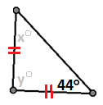 | 36.  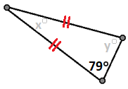 | 37.  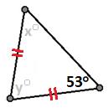
38.  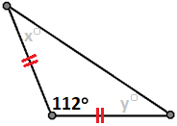 | 39.  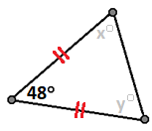 | 40.  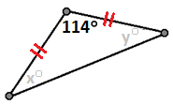

41. | Author Michael Serra of the textbook Discovering Geometry developed a problem that applies the triangle sum and base angles of an isosceles triangle are congruent. Prove what each angle should be in order to maintain properties of triangles. | 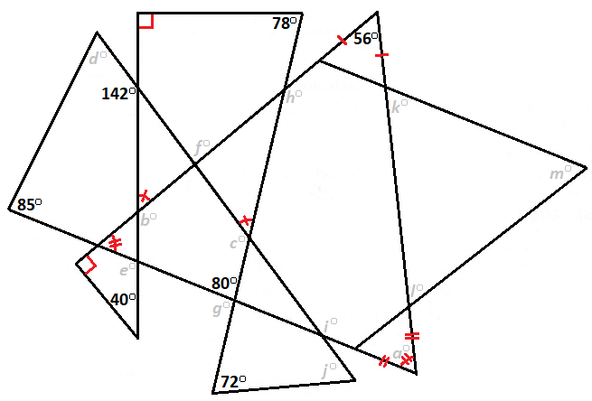

For #42-47, write the measure of each numbered angle by applying prior knowledge of angle pairs and the triangle sum.
42.  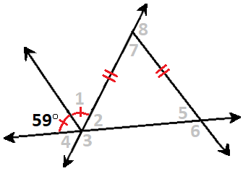 | 43.  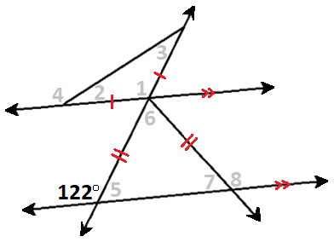
44.  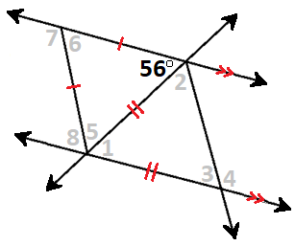 | 45.  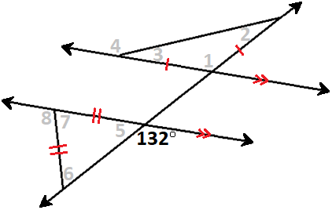
46.  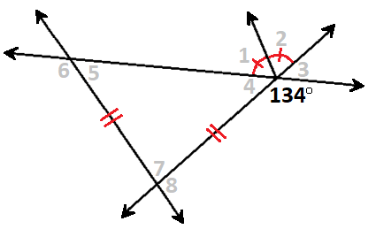 | 47.  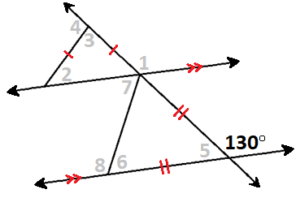

For #48-53, write the measure of each lettered angle by applying prior knowledge of angle pairs and the triangle sum.
48.  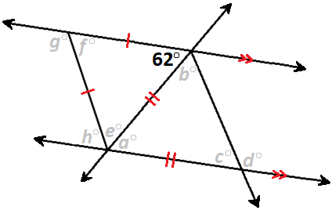 | 49.  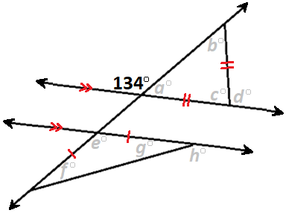
50.  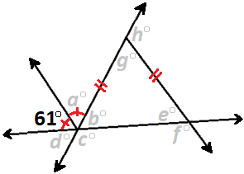 | 51.  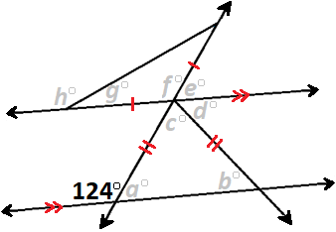
52.  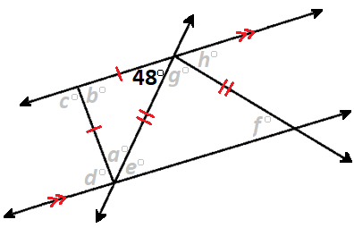 | 53.  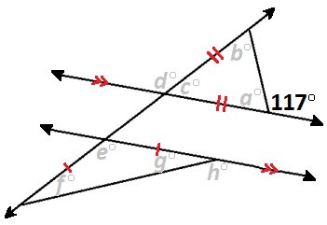

54. | The Howe Truss is one of several framework designs that supports a roof. This design was created by American architect William Howe in 1846 using congruent base angles of isosceles triangles. Prove what each angle measure should be in order for the framework to contain isosceles triangles.
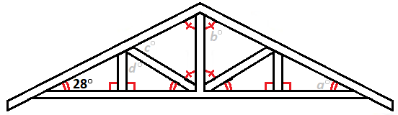 |  | 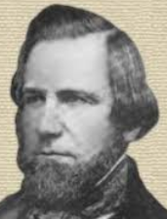  William Howe,  Architect  1803-1852

VOCABULARY
Midsegment – a segment that joins the midpoints of two sides of a triangle.
Triangle Midsegment Theorem – If a segment is a midsegment, then the segment is parallel to the third side and
half the length of the third side.
Triangle Proportionality Converse Theorem - If a line divides two sides of a triangle proportionally, then the line is parallel to the third side of the triangle.
Corresponding Angles Postulate - If parallel lines are intersected by a transversal,
then corresponding angles (translations of angles) are congruent.

For #55-56, complete the statements and justifications for each two-column proof
to prove the Triangle Midsegment Theorem.
55. | Given: DE is a midsegment  Prove: DE || BC and DE = ½BC | 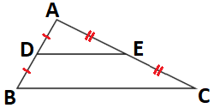 | 56. | Given: MN is a midsegment  Prove: MN || RG and MN = ½RG | 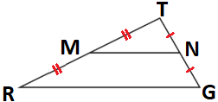

Step | Statement | Justification |  | Step | Statement | Justification
1 | DE is a midsegment | Given |  | 1 | MN is a midsegment | Given
2 | AD = ___ , AE = ___ | Definition of midsegment |  | 2 | TM = ___ , TN = ___ | Definition of midsegment
3 | $\frac{AD}{DB}=__,$ $\frac{AE}{EC}=__$ | Property of Proportions |  | 3 | $\frac{TM}{MR}=__,$ $\frac{TN}{NG}=__$ | Property of Proportions
4 | $$\frac{AD}{DB}=\frac{}{}$$ | Substitution |  | 4 | $$\frac{TM}{MR}=\frac{}{}$$ | Substitution
5 | DE || BC | Triangle Proportionality Converse Theorem |  | 5 | MN || RG | Triangle Proportionality Converse Theorem
6 | ∠ADE ≅ ∠______,  ∠AED ≅ ∠______, | Corresponding Angles Postulate |  | 6 | ∠TMN ≅ ∠______,  ∠TNM ≅ ∠______ | Corresponding Angles Postulate
7 | ΔADE ∼ Δ______ | Angle Angle Similarity (AA~) |  | 7 | ΔTMN ∼ Δ______ | Angle Angle Similarity (AA~)
8 | __ is the midpoint of AB,  __ is the midpoint of AC | Definition of midsegment |  | 8 | __ is the midpoint of TR,  __ is the midpoint of TG | Definition of midsegment
9 | AD = ½___, AE = ½___ | Definition of midpoint |  | 9 | TM = ½___, TN = ½___ | Definition of Midpoint
10 | DE = ½BC | Corresponding Sides of Similar Triangles are Proportional |  | 10 | MN = ½RG | Corresponding Sides of Similar Triangles are Proportional

For #57-62, use the given info to prove that LM, MN and NL are midsegments of ΔABC.
Find the perimeters of ΔLMN and ΔABC followed by the ratio of perimeters for ΔLMN:ΔABC.
57. AC = 108, LM = 45, CL = 41  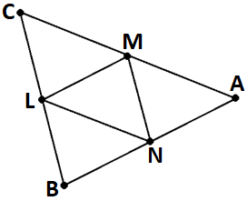  $$\frac{Perimeter ∆LMN}{Perimeter ∆ABC}=\frac{ }{ } =\frac{ }{ }$$ | 58. AB = 64, MN = 44, AM = 58  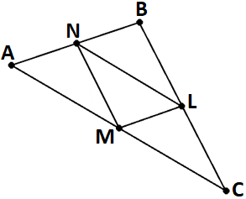  $$\frac{Perimeter ∆LMN}{Perimeter ∆ABC}=\frac{ }{ } =\frac{ }{ }$$ | 59. BC = 62, LN = 57, BN = 51  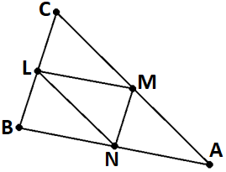  $$\frac{Perimeter ∆LMN}{Perimeter ∆ABC}=\frac{ }{ } =\frac{ }{ }$$

60. NM = 37, NB = 36, CA = 80  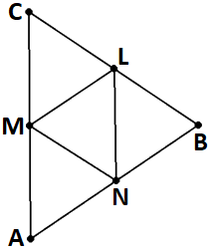  $$\frac{Perimeter ∆LMN}{Perimeter ∆ABC}=\frac{ }{ } =\frac{ }{ }$$ | 61. AM = 33, ML = 64, CB = 108  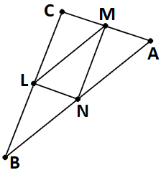  $$\frac{Perimeter ∆LMN}{Perimeter ∆ABC}=\frac{ }{ } =\frac{ }{ }$$ | 62. MC = 52, BA = 76, NM = 46  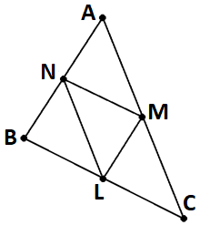  $$\frac{Perimeter ∆LMN}{Perimeter ∆ABC}=\frac{ }{ } =\frac{ }{ }$$

For #63-68, use the given info to write all the angles of ΔABC and ΔMLC to prove that LM is a midsegment of ΔABC.
63.  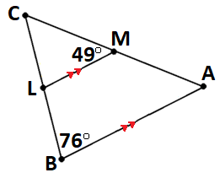 | 64.  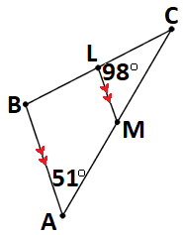 | 65.  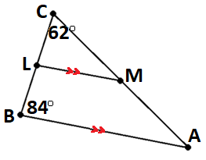
66.  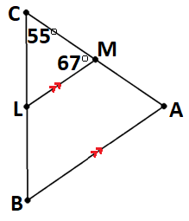 | 67.  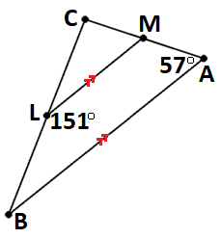 | 68.  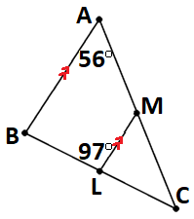

For #69-70, the Bermuda Triangle is displayed with Bermuda (B), Florida (F) and Puerto Rico (P) as vertices of ΔBFP.
The triangle has been minimized to a central area of interest to ΔLTG.
69. | Find all linear angles within ΔBFP to prove that  LT, TG, and GL are all midsegments.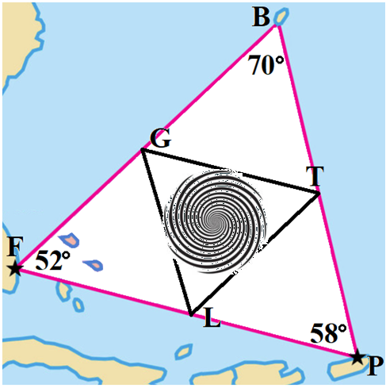 | 70. | Find the side lengths of ΔLTG to prove that  LT, TG, and GL are all midsegments.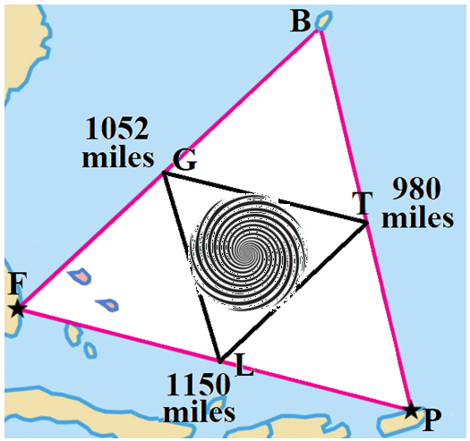
VOCABULARY
Median | Concurrent Point | Concurrence of Medians Theorem | Midpoint Formula
a segment whose endpoints are a vertex of a triangle and the midpoint of the opposite side. Any triangle has 3 medians. | The point where three or more lines intersect inside a triangle. | The medians of a triangle meet at one point. | Given two points A(x₁, y₁) and B(x₂, y₂), the coordinates of the midpoint M of line segment AB is  M( x, y ) = $\left(\frac{x_{1}+x_{2}}{2},\frac{y_{1}+y_{2}}{2}\right)$

For #71-72, complete the statements and justifications for each two-column proof
to prove the Concurrence of Medians Theorem.

71. | Given: L, M, and N are midpoints of ΔABC  Prove: AL, BM and CN are medians that meet at point P | 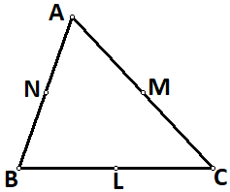 | 72. | Given: L, M, and N are midpoints of ΔTRG  Prove: TL, RM and GN are medians that meet at point P | 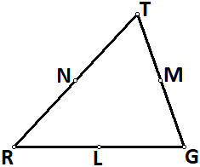

Step | Statement | Justification |  | Step | Statement | Justification
1 | L, M, and N are midpoints of ΔABC | Given |  | 1 | L, M, and N are midpoints of ΔTRG | Given
2 | Construct medians ___, ___ and ___ | Definition of median |  | 2 | Construct medians ___, ___ and ___ | Definition of median
3 | Label concurrent point P. | Definition of  concurrent point |  | 3 | Label concurrent point P. | Definition of  concurrent point
4 | AL, BM and CN are medians that meet at point P | Definition of median and concurrent point |  | 4 | TL, RM and GN are medians that meet at point P | Definition of median and concurrent point

73. | Three friends visit White Water Six Flags. One decides to go to the Caribbean Plunge at point  C( -7, 9 ), another to the Tornado at point  T(-8, -8), and the last to Run-A-Way River at point R(9, -10). After one hour, each friend agrees that the meeting point should be the Atlanta Wave Ocean at concurrent point O.  Step 1: Complete the chart to find the midpoints L, M and N.  Midpoint Coordinates  L of TR L( , )  M of RC M( , )  N of CT N( , )  Step 2: Draw the medians CL, TM and RN.  Step 3: Label the Atlanta Wave Ocean concurrent point O.  Step 4: Write the coordinates of point  O( , ). | 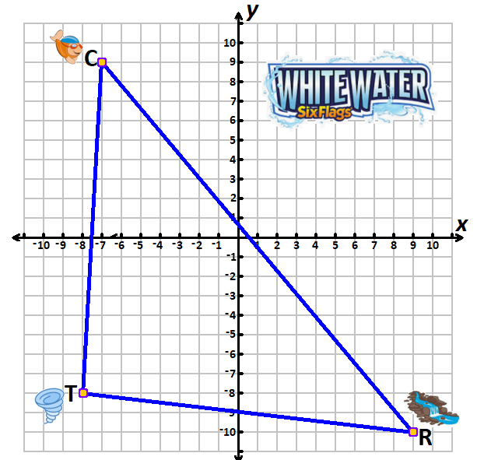

74. | Three friends visit Six Flags Over Georgia. One decides to go to the Hurricane Harbor at point H( 8, 4 ), another to the Pandemonium Ride at point P(-8, -2), and the last to the Daredevil Ride at point D(-3, -8). After one hour, all agree that the meeting point should be the Superman Tower of Power at concurrent point O.  Step 1: Complete the chart to find the midpoints L, M and N.  Midpoint Coordinates  L of PD L( , )  M of DH M( , )  N of HP N( , )  Step 2: Draw the medians HL, PM and DN.  Step 3: Label the Superman Tower of Power concurrent point O.  Step 4: Write the coordinates of point O( , ). | 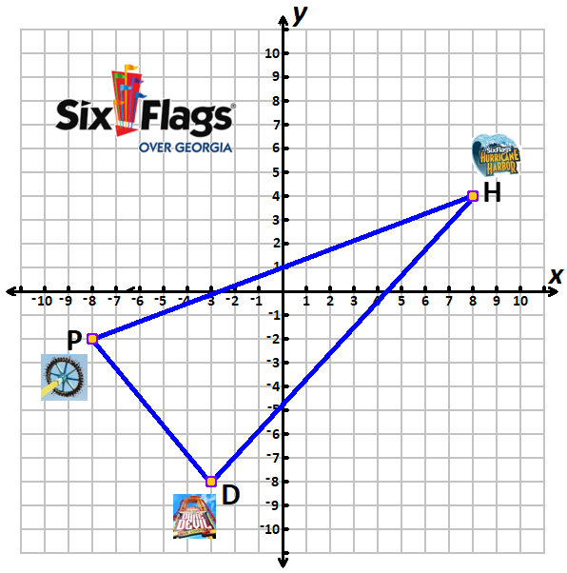

75. | Three friends visit Zoo Atlanta. One decides to stay at Flamingo Plaza at point F( 6, -8 ), another to Giraffe Plains at point G(-5, -4), and the last to the Giant Panda Forest at point P( 5, 9 ). After one hour, all agree that the meeting point should be at Ben and Jerry’s Ice Cream at concurrent point O.  Step 1: Complete the chart to find the midpoints L, M and N.  Midpoint Coordinates  L of GF L( , )  M of FP M( , )  N of GP N( , )  Step 2: Draw the medians PL, GM and FN.  Step 3: Label the Ben and Jerry’s Ice Cream concurrent point O.  Step 4: Write the coordinates of point O( , ). | 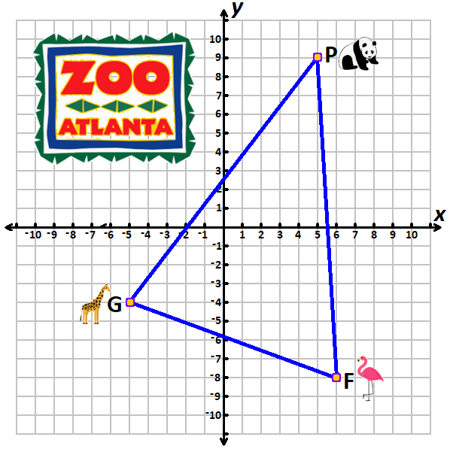
76. | Three friends visit the Georgia Aquarium. One decides to go to the Ocean Voyager at point V( 9, 8 ), another to Dolphin Tales at point D(-5, -3), and the last to Georgia Explorer at point G( 5, -8). After one hour, all agree that the meeting point should be the central lobby at concurrent point O.  Step 1: Complete the chart to find the midpoints L, M and N.  Midpoint Coordinates  L of DG L( , )  M of GV M( , )  N of VD N( , )  Step 2: Draw the medians VL, DM and GN.  Step 3: Label the central lobby concurrent point O.  Step 4: Write the coordinates of point O( , ). | 