VOCABULARY
Postulate – a statement that is accepted as true without proof.
Theorem – a statement that is proven true from given information, postulates and previously proved theorems.
Two-column proof - a series of statements and reasons often displayed in a chart that works from given
information to the statement that needs to be proven.

Adjacent | Supplementary | Linear Pair | Vertical Angle Theorem
Two angles with the same vertex and a common side | Two angles not necessarily adjacent whose measures sum to 180°. | Two angles on a line with the same vertex and a common side whose measures sum to 180°. | 180° rotation of angles about a common vertex are congruent.
∠1 and ∠___ are _________________  angles. | ∠1 and ∠___ are ________________ angles  with m∠1 + m ∠2 = ____°. | ∠1 and ∠___ are  a linear pair that is both ___________________ and  ______________________ | ∠1 and ∠___ are vertical angles with ∠1 ≅ ∠___.  ∠2 and ∠___ are also vertical angles with ∠2 ≅ ∠___.

For #1-2, complete the statements and justifications for each two-column proof to prove the Vertical Angles Theorem.
1. | Given: Line m intersects line n  Prove: ∠1 ≅ ∠3 |  | 2. | Given: Line m intersects line n  Prove: ∠2 ≅ ∠4

Step | Statement | Justification |  | Step | Statement | Justification
1 | Line m intersects  line n | Given |  | 1 | Line m intersects  line n | Given
2 | ∠1 and ∠2 form a linear pair.  ∠2 and ∠3 form a linear pair. | Definition of linear pair |  | 2 | ∠2 and ∠3 form a linear pair.  ∠3 and ∠4 form a linear pair. | Definition of linear pair
3 | m∠1 + m ∠2 = _____°  m∠2 + m ∠3 = _____° | Angles that form a linear pair have measures that sum to 180°. |  | 3 | m∠2 + m ∠3 = _____°  m∠3 + m ∠4 = _____° | Angles that form a linear pair have measures that sum to 180°.
4 | m∠1 + m ∠2  = m∠2 + m ∠3 | Substitution |  | 4 | m∠2 + m ∠3  = m∠3 + m ∠4 | Substitution
5 | m∠1 = m ∠3 | Subtraction of m ∠2 |  | 5 | m∠2 = m ∠4 | Subtraction of m ∠3
6 | ∠1 ≅ ∠3 | Definition of congruent angles |  | 6 | ∠2 ≅ ∠4 | Definition of congruent angles

3. | Light sabers clash to form two pairs of vertical angles. Find the unknown ? angle measures. |  |  | 4. | This time, two Jedi light sabers clash with one Sith light saber to form four pairs of vertical angles. Find the missing ? angle measures.
For #5-8, a fan has been spread out. Use the definition of linear pair and congruent angles to help find the missing ? angles.
5. | 6. | 7. | 8.

For #9-12, some warped fidget spinner has some angle measurements.
Use the definition of linear pair and congruent angles to help find the missing ? angles.
9. | 10. | 11. | 12.
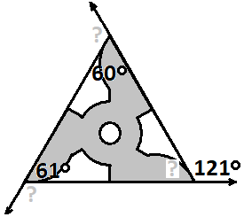 | 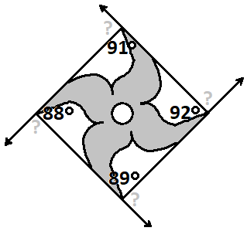 |  | 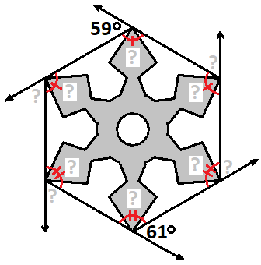

For #13-15, each pizza was directly sliced in half either horizontally or vertically but not all the pieces were sliced evenly.
Use the definition of linear pair and vertical angles are congruent to help find the missing ? angles.
13. | 14. | 15.

For #16-18, each pie was directly sliced in half horizontally and vertically but not all the pieces were sliced evenly. Use the definition of linear pair, the definition of vertical angles and vertical angles are congruent to help find the missing ? angles.
16. | 17. | 18.
VOCABULARY
Postulate – a statement that is accepted as true without proof.
Theorem – a statement that is proven true from given information, postulates and previously proved theorems.
Two-column proof - a series of statements and reasons often displayed in a chart that works from given
information to the statement that needs to be proven.
Transversal – a line that cuts parallel lines into angle pairs.

Corresponding Angles Postulate – If two parallel lines are cut by a transversal,
then corresponding angles (translations of angles) formed by the transversal are congruent.
In this diagram, line m is parallel to line n.
∠1 and ∠___ are corresponding angles with ∠1 ≅ ∠___.
∠2 and ∠___ are corresponding angles with ∠2 ≅ ∠___.
Alternate Interior Angles Theorem – If two parallel lines are cut by a transversal, then alternate interior angles (180° rotations of interior angles) formed by the transversal are congruent.
In this diagram, line m is parallel to line n.
∠3 and ∠___ are alternate interior angles with ∠3 ≅ ∠___.
∠4 and ∠___ are alternate interior angles with ∠4 ≅ ∠___.

For #19-20, complete the statements and justifications for each two-column proof to prove
the Alternate Interior Angles Theorem.
19. | Given: Line m is parallel to line n  Prove: ∠4 ≅ ∠5 |  | 20. | Given: Line m is parallel to line n  Prove: ∠3 ≅ ∠6

Step | Statement | Justification |  | Step | Statement | Justification
1 | Line m is parallel to line n | Given |  | 1 | Line m is parallel to line n | Given
2 | ∠1 ≅ ∠___ | Corresponding Angles Postulate |  | 2 | ∠2 ≅ ∠___ | Corresponding Angles Postulate
3 | ∠1 ≅ ∠___ | Vertical angles are congruent |  | 3 | ∠2 ≅ ∠___ | Vertical angles are congruent
4 | ∠4 ≅ ∠5 | Substitution |  | 4 | ∠3 ≅ ∠6 | Substitution

21. | Ocean waves move in parallel lines toward the shore. Two windsurfers streak through waves where the paths act as transversals. What should be the measures of the unknown angles? |  | 22. | What should the values of x and y on this trajectory of the cue ball with a pair of parallel lines to pocket the 7 ball before the 8 ball?

23. | What should the values of a, b, c, d, e, and f on this path with parallel lines to sink this air hockey puck in the opponent’s goal? | 24. | What should the values of a, b, c, d, e, and f on this path with parallel lines to sink this golf ball in a miniature golf ball hole in one?
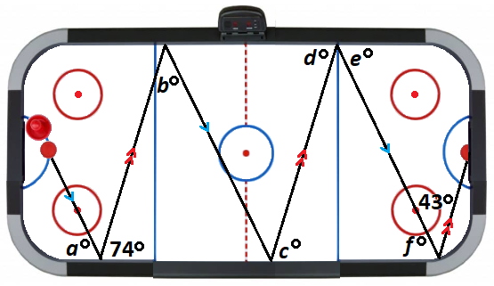

Alternate Exterior Angles Theorem – If two parallel lines are cut by a transversal, then alternate exterior angles (180° rotations of exterior angles) formed by the transversal are congruent.
In this diagram, line m is parallel to line n.
∠1 and ∠___ are alternate interior angles with ∠1 ≅ ∠___.
∠2 and ∠___ are alternate interior angles with ∠2 ≅ ∠___.

For #25-26, complete the statements and justifications for each two-column proof to prove
the Alternate Exterior Angles Theorem.
25. | Given: Line m is parallel to line n  Prove: ∠1 ≅ ∠8 |  | 26. | Given: Line m is parallel to line n  Prove: ∠2 ≅ ∠7

Step | Statement | Justification |  | Step | Statement | Justification
1 | Line m is parallel to line n | Given |  | 1 | Line m is parallel to line n | Given
2 | ∠1 ≅ ∠___ | Corresponding Angles Postulate |  | 2 | ∠2 ≅ ∠___ | Corresponding Angles Postulate
3 | ∠5 ≅ ∠___ | Vertical angles are congruent |  | 3 | ∠6 ≅ ∠___ | Vertical angles are congruent
4 | ∠1 ≅ ∠8 | Substitution |  | 4 | ∠2 ≅ ∠7 | Substitution

Same Side Interior Angles Theorem – If two parallel lines are cut by a transversal, then same side interior angles formed by the transversal are supplementary.
In this diagram, line m is parallel to line n.
∠3 and ∠___ are same side interior angles with m∠3 + m∠___= 180°.
∠4 and ∠___ are alternate interior angles with m∠3 + m∠___= 180°.
Same Side Exterior Angles Theorem – If two parallel lines are cut by a transversal, then same side exterior angles formed by the transversal are supplementary.
In this diagram, line m is parallel to line n.
∠1 and ∠___ are same side exterior angles with m∠1 + m∠___= 180°.
∠2 and ∠___ are alternate exterior angles with m∠2 + m∠___= 180°.

For #27-28, complete the statements and justifications for each two-column proof to prove
the Same Side Interior Angles Theorem.
27. | Given: Line m is parallel to line n  Prove:  m∠3 = 180° − m∠5 |  | 28. | Given: Line m is parallel to line n  Prove:  m∠4 = 180° − m∠6

Step | Statement | Justification |  | Step | Statement | Justification
1 | Line m is parallel to line n | Given |  | 1 | Line m is parallel to line n | Given
2 | ∠1 ≅ ∠___ | Corresponding Angles Postulate |  | 2 | ∠2 ≅ ∠___ | Corresponding Angles Postulate
3 | m∠1 = m∠___ | Definition of congruent angles |  | 3 | m∠2 = m∠___ | Definition of congruent angles
4 | ∠1 and ∠___ are a  linear pair | Definition of  linear pair |  | 4 | ∠2 and ∠___ are a  linear pair | Definition of  linear pair
5 | m∠1 + m∠___ = 180° | Angles that form a linear pair have measures that sum to 180°. |  | 5 | m∠2 + m∠___ = 180° | Angles that form a linear pair have measures that sum to 180°.
6 | m∠3 + m∠5 = 180° | Substitution |  | 6 | m∠___ + m∠___ = 180° | Substitution
7 | m∠3 = 180° − m∠5 | Subtraction |  | 7 | m∠___ = 180° − m∠___ | Subtraction

For #29-30, complete the statements and justifications for each two-column proof to prove
the Same Side Exterior Angles Theorem.
29. | Given: Line m is parallel to line n  Prove:  m∠1 = 180° − m∠7 |  | 30. | Given: Line m is parallel to line n  Prove:  m∠2 = 180° − m∠6

Step | Statement | Justification |  | Step | Statement | Justification
1 | Line m is parallel to line n | Given |  | 1 | Line m is parallel to line n | Given
2 | ∠1 ≅ ∠___ | Corresponding Angles Postulate |  | 2 | ∠2 ≅ ∠___ | Corresponding Angles Postulate
3 | m∠1 = m∠___ | Definition of congruent angles |  | 3 | m∠2 = m∠___ | Definition of congruent angles
4 | ∠5 and ∠___ are a  linear pair | Definition of  linear pair |  | 4 | ∠6 and ∠___ are a  linear pair | Definition of  linear pair
5 | m∠5 + m∠___ = 180° | Angles that form a linear pair have measures that sum to 180°. |  | 5 | m∠6 + m∠___ = 180° | Angles that form a linear pair have measures that sum to 180°.
6 | m∠1 + m∠___ = 180° | Substitution |  | 6 | m∠___ + m∠___ = 180° | Substitution
7 | m∠1 = 180° − m∠7 | Subtraction |  | 7 | m∠___ = 180° − m∠___ | Subtraction
VOCABULARY
Perpendicular Bisector – A line that intersects a line segment at the line segment’s midpoint and at right angles.
Perpendicular Bisector Theorem – Any point on the perpendicular bisector of a line segment is equidistant from the endpoints of the segment.
In the diagram, line CD is the perpendicular bisector of line segment AB.
$\overset{⃡}{CD}$⊥ ____, CA ≅ ____, MA ≅ ____, and DA ≅ ____,

For #31-32, complete the statements and justifications for each two-column proof to prove
the Perpendicular Bisector Theorem.
31. | Given: CD is the perpendicular bisector of AB  Prove:  AC ≅ BC |  | 32. | Given: GH is the perpendicular bisector of EF  Prove:  EG ≅ FG

Step | Statement | Justification |  | Step | Statement | Justification
1 | CD is the perpendicular bisector of AB | Given |  | 1 | GH is the perpendicular bisector of EF | Given
2 | AD ≅ ___ | Definition of Bisector |  | 2 | EH ≅ ___ | Definition of Bisector
3 | CD ≅ ___ | Reflexive Sides are congruent |  | 3 | GH ≅ ___ | Reflexive Sides are congruent
4 | ∠ADC and ∠______ are right angles | Definition of Perpendicular |  | 4 | ∠EHG and ∠______ are  right angles | Definition of Perpendicular
5 | ∠ADC ≅ ∠_____ | All right angles are congruent |  | 5 | ∠EHG ≅ ∠_____ | All right angles are congruent
6 | ΔADC ≅ Δ_____ |  |  | 6 | ΔEHG ≅ Δ_____
7 | AC ≅ BC |  |  | 7 | EG ≅ FG

33. | A perpendicular bisector goes through the width of each kite. Write and solve a process for determining the perimeter of each kite. | 34. | The Stealth Bomber has dimensions shown with a perpendicular bisector going through the length of the wingspan. Write and solve a process for determining the values of x and y.  