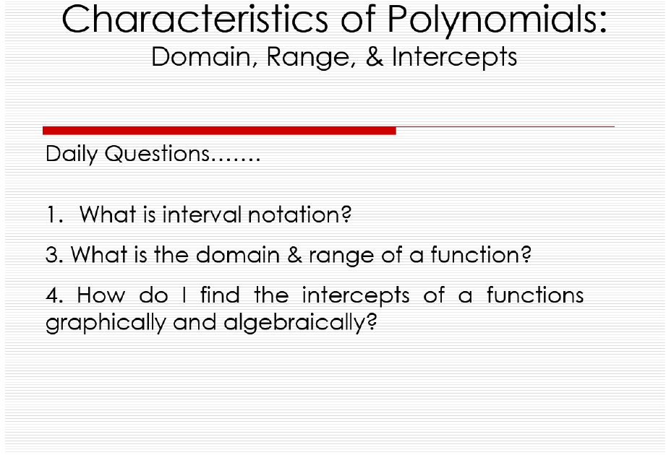



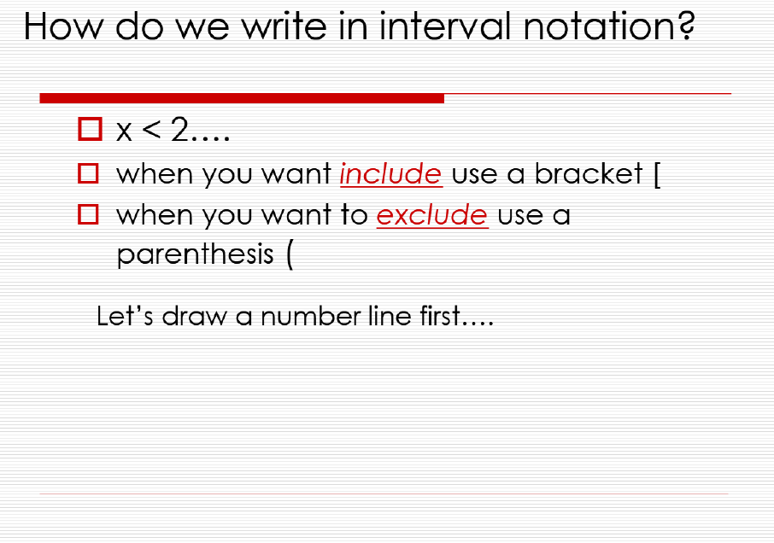

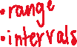

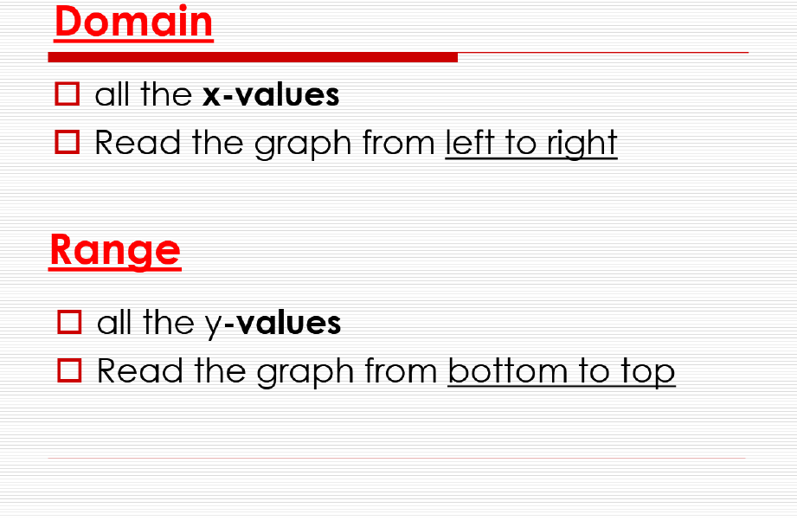

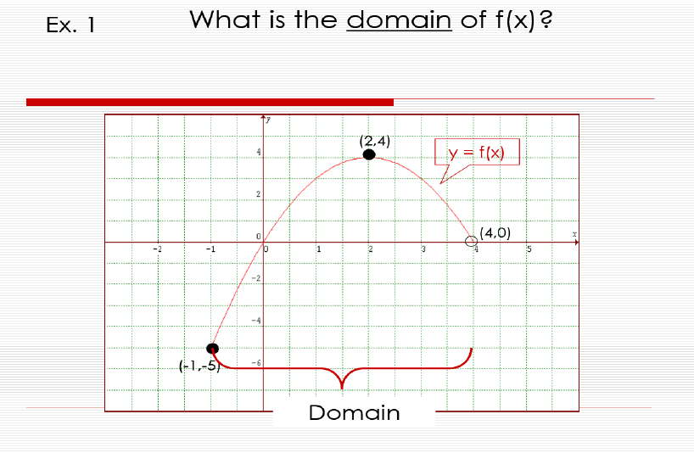



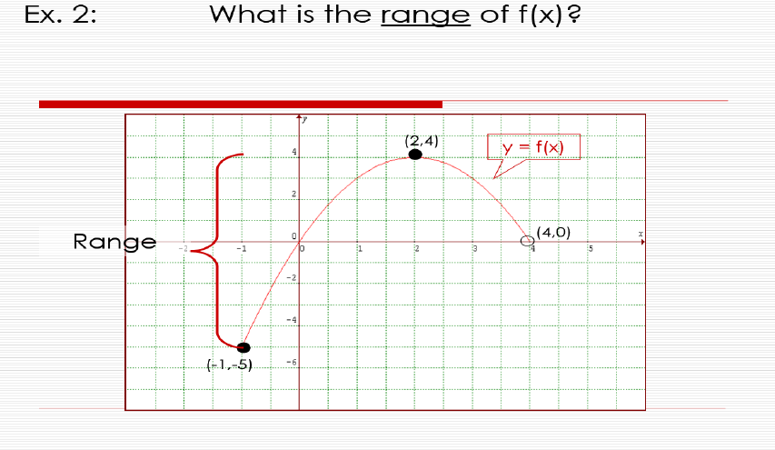



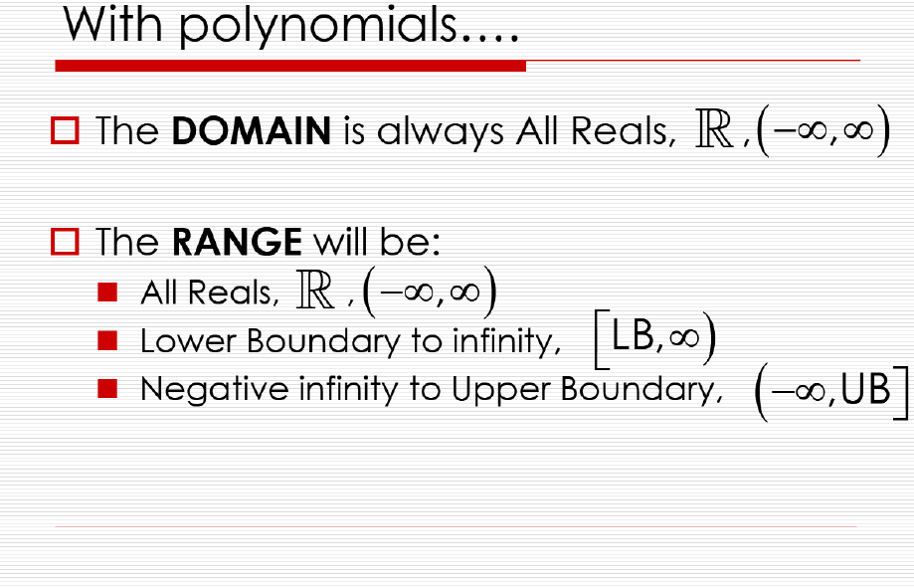

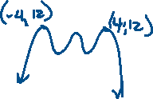

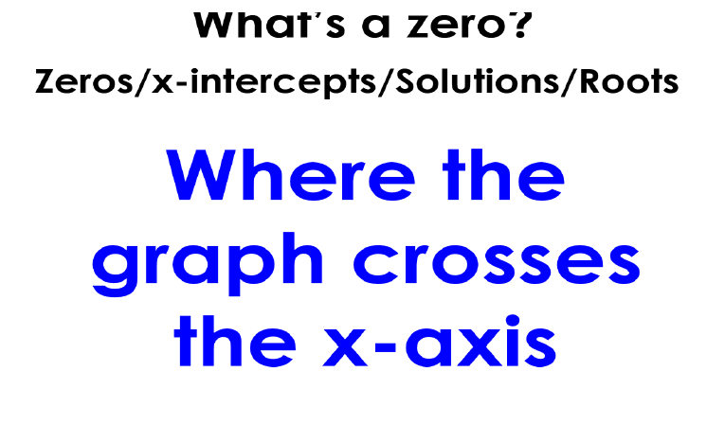



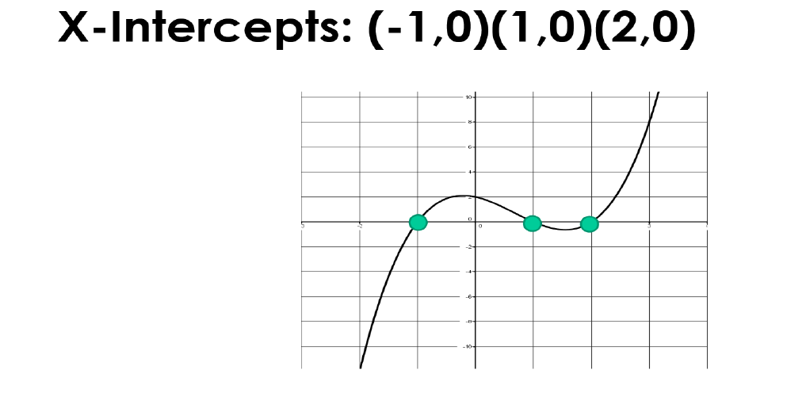



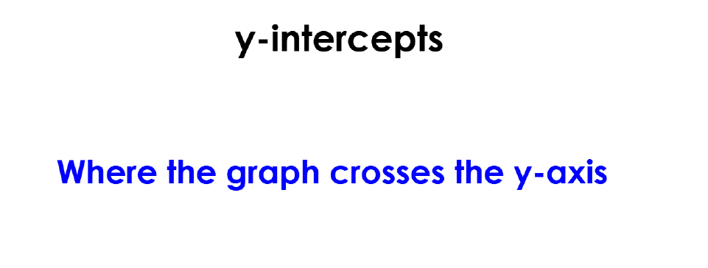

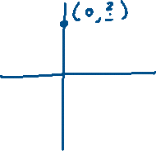





y-intercept (0, 2)



**Identify the following characteristics given the graph:**



1. Domain:



Range:



Zeros:

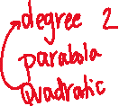

Y-intercept:







1. Domain:



Range:



Zeros:



Y-intercept:

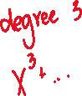



1. Domain:

Range:

Zeros:

Y-intercept:



1. Domain:

Range:

Zeros:

Y-intercept:

**Determine the number of zeros, y-intercept, & find the domain:**



1.  6. 

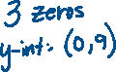

**EXTREMA**



In [mathematical analysis](https://en.m.wikipedia.org/wiki/Mathematical_analysis), the maxima and minima (the respective plurals of maximum and minimum) of a [function](https://en.m.wikipedia.org/wiki/Function_(mathematics)), known collectively as extrema (the plural of extremum), are **the largest and smallest value of the function**, either within a given range (the local or relative extrema) or on the entire [domain of a function](https://en.m.wikipedia.org/wiki/Domain_of_a_function) (the global or absolute extrema).

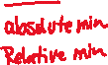

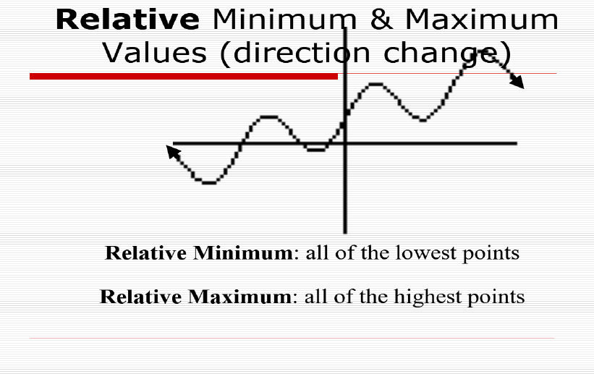

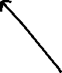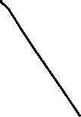

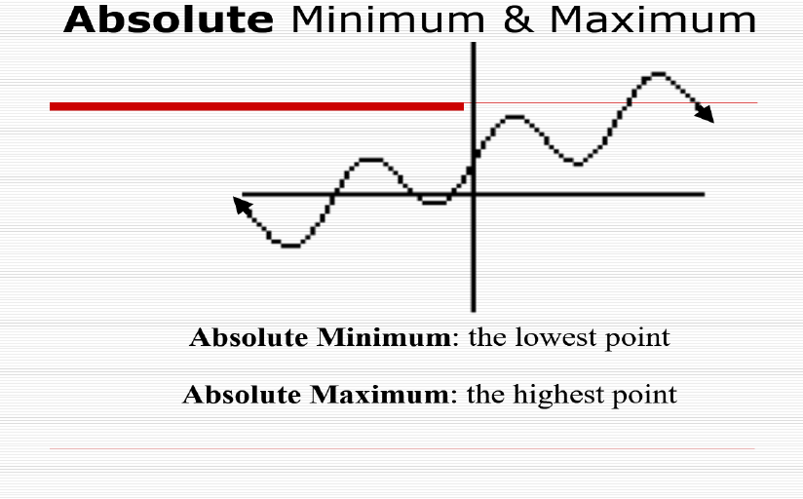

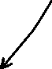

|  |  |  |  |  |
| --- | --- | --- | --- | --- |
|  | **Increasing, Decreasing, & Constant** | | **Extremas** | |
| **7.** | **Increasing** |  | **Absolute Minimum** |  |
| **Decreasing** |  | **Absolute Maximum** |  |
| **Constant** |  | **Relative Minimum(s)** |  |
|  |  | **Relative Maximum(s)** |  |
| **8.** | **Increasing** |  | **Absolute Minimum** |  |
| **Decreasing** |  | **Absolute Maximum** |  |
| **Constant** |  | **Relative Minimum(s)** |  |
|  |  | **Relative Maximum(s)** |  |
| **9.** | **Increasing** |  | **Absolute Minimum** |  |
| **Decreasing** |  | **Absolute Maximum** |  |
| **Constant** |  | **Relative Minimum(s)** |  |
|  |  | **Relative Maximum(s)** |  |

